EXERCISE 1.2

**NCERT Solutions for Class 10 Chapter 1-**

**Real Numbers**

EXAMBUDDY

Question 1:  
Prove that √5 is irrational.  
Solution:  
Let √5 = p/q be a rational number, where p and q are co-primes and q ≠ 0.  
Then, √5q = p

=> 5q2=p2⇒  p2 = 5q2     … (i)  
Since 5 divides p2, so it will divide p also.  
Let p = 5r  
Then p2 – 25r 2     [Squaring both sides]  
⇒ 5q2 = 25r2     [From(i)]  
⇒ q2 = 5r2Since 5 divides q2, so it will divide q also. Thus, 5 is a common factor of both p and q.

This contradicts our assumption that √5 is rational.  
Hence, √5 is irrational. Hence, proved.

Question 2:  
Prove that 3 + 2√5 is irrational.  
Solution:

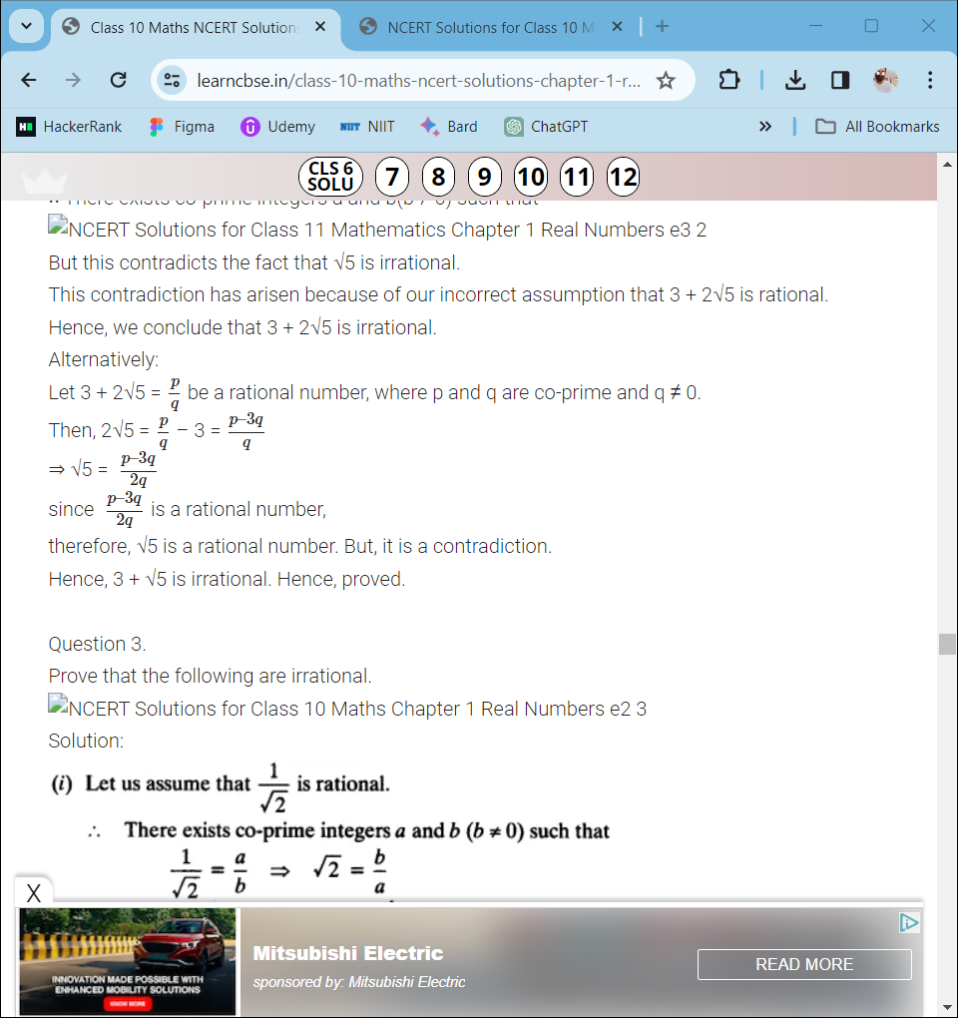

Question 3:  
Prove that the following are irrationals:

**NCERT Solutions for Class 10 Chapter 1-**

**Real Numbers**

EXAMBUDDY

1. 1/√2

Solution

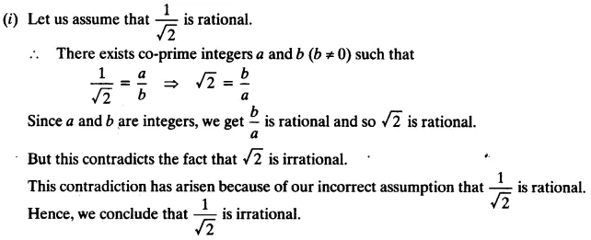

1. 7√5

Solution

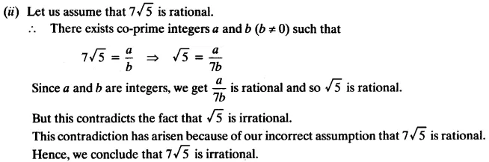

1. 6 + √2

Solution

